Exploratory Data Analysis on the UsArrest Dataset
Report

Introduction
The dataset chosen for this project is the UsArrest, which shows the names of states in the United States where arrest was made. The dataset set shows how murder rates per state, how assaults per state, how rape incidents per state as well as the Urban population. The program begins by importing all relevant libraries needed to analyze and visualize the dataset.
Data cleaning
The summary of the methods and visualizations done during the data cleaning is involved. The head method was used to display the first five states in a row format as well as the murder, assault, UrbanPop and rape columns. The murder and rape datasets were converted into type int so that it would be easier to visualize the data. It is crucial to know the size of the dataset and therefore the shape method was implemented to return the number of rows and columns of the dataset.
Missing Data
The missing_values_count variable was used to store the total sums of missing values, per column. The analysis identified no missing values.
Data stories and visualizations
The program calculates and displays the murder, assault, rape incidents and urban population per state. It calculates and displays the states with highest and lowest murder, assault, rape and urban population.

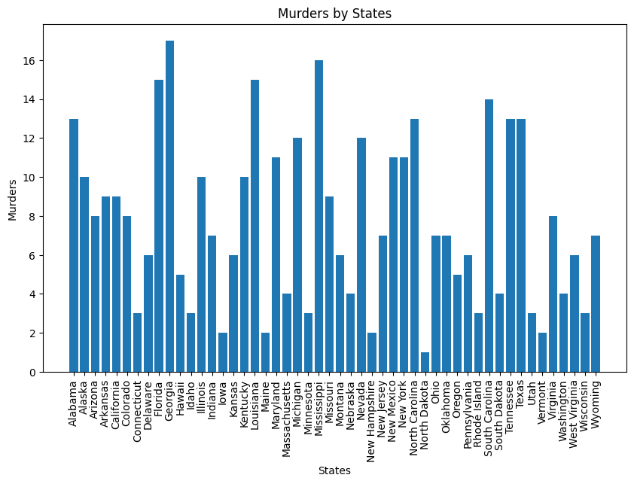
Georgia has the highest murder rates and North Dakota has the lowest murder rates according to the bar chart.
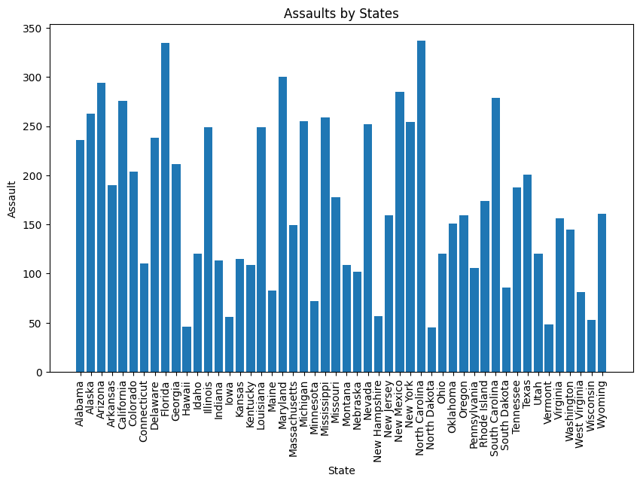
Florida and Carolina have the highest assault incidents. Hawaii and North Dakota have the lowest assault incidents according to the Bar chart.
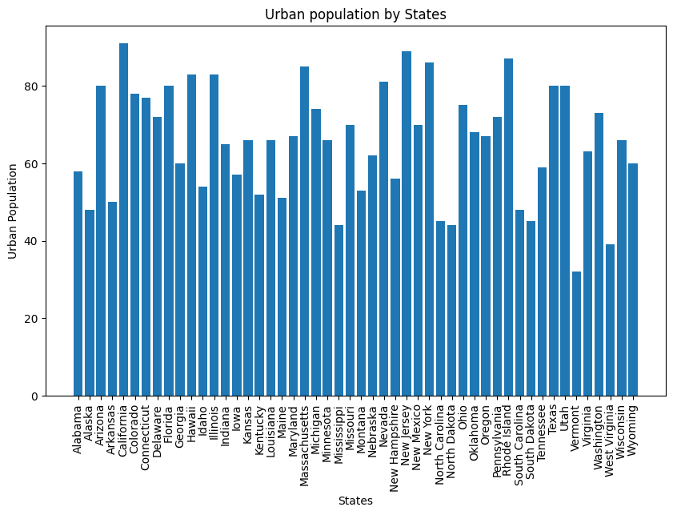
California has the highest urban population, and Vermont has the lowest urban population according to the Bar chart.
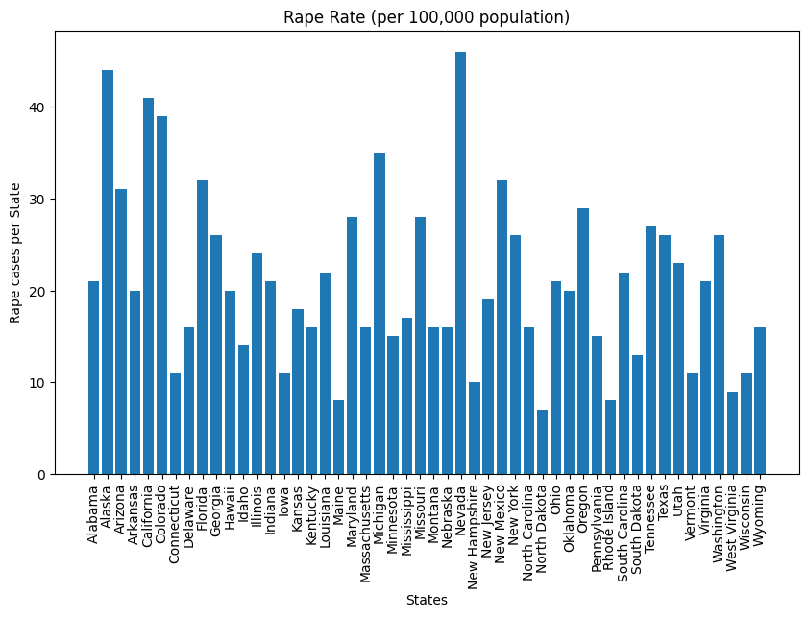
Nevada has the highest rape case per 100,000 people and North Dakota has the lowest rape cases per 100,000 people according to bar chart data.
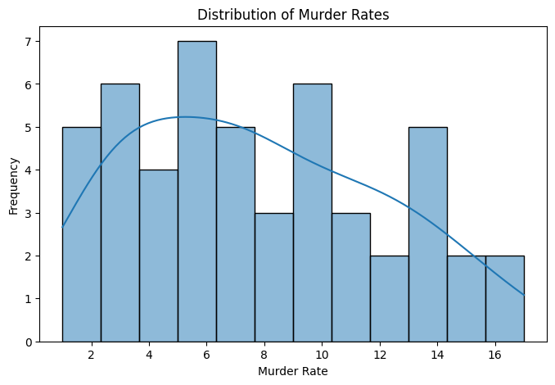
The distribution of murder rates, histogram shape shows that most states have relatively low to moderate murder rates, while a few states display very high murder rates.
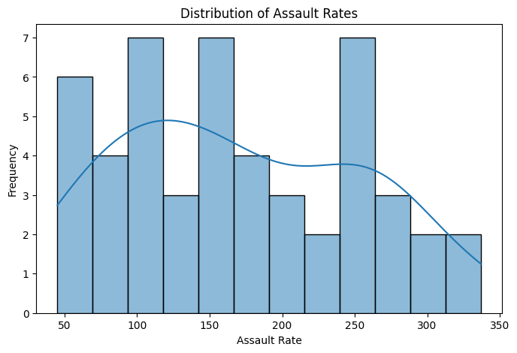
The distribution of assault cases histogram indicates that assault rates vary considerably with most states recording low to moderate assault rates and a smaller number of states experiencing a much higher rate.
The distribution of urban population histogram indicates that most states have moderate to high levels of urbanization, while only a few states have relatively low urban population percentages. The histogram is useful for examining how urban population percentages are distributed across the dataset and identifying whether the data is concentrated within a particular range. Unlike the crime rate variables, the urban population variable does not contain extreme outliers, indicating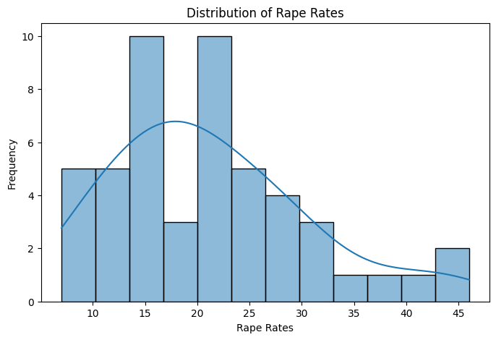ing a more balanced spread of values.

The distribution of rape indicates that most states have low to moderate rape rates, while a smaller number of states record comparatively higher rates. This indicates that higher rape rates are less common across the dataset.
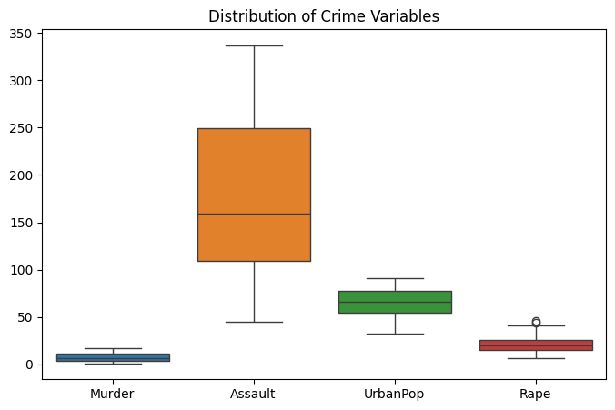
The Boxplot is used in the murder, assault, urbanPop and rape dataset. It displays the median, interquartile range (IQR), overall spread of the data and any potential outliers for each variable, making it easy to compare their distribution. The assault variable exhibits the greatest variability, as indicated by its wider box and longer whiskers. This suggest that assault rates differ considerably amongst states. In contrast murder and rape variables show smaller spread, indicating less variation in their rates. The urbanPop variable appears to have the most consistent distribution, with values concentrated within a narrower range.
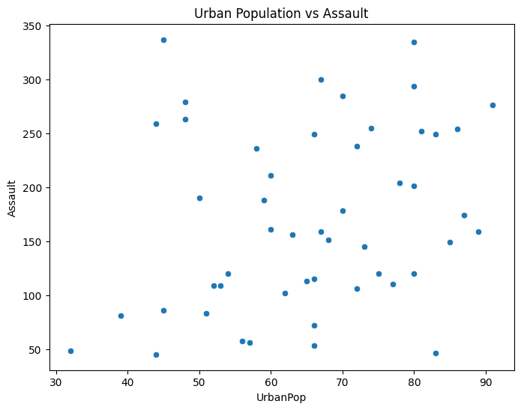
The scatter plot urban vs assault. The scatterplot displays the relationship between the percentage of the urban population and assault rates across the states. The distribution of points suggests that there is no strong linear relationship between urban population and assault rates. Although some states with higher urban population percentages also record high assault rates, there are many exceptions, indicating that urbanization alone does not fully explain differences in assault rates across states.
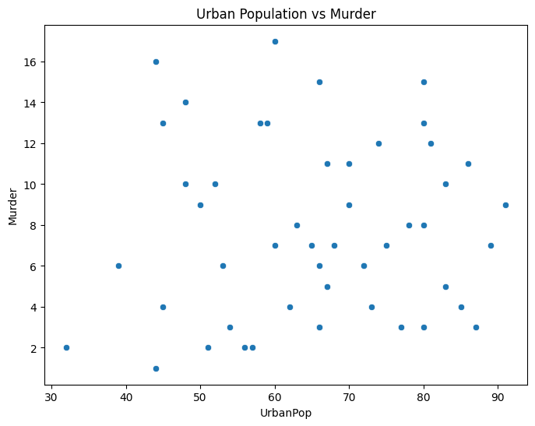
Scatter plot murder vs Urban population. Each point in the relationship between murder and urban population represents a single state, with its position determined by its urban population percentage on the x-axis and its murder rate on the y-axis. The distribution of the data points suggests that there is no strong linear relationship between urban population and murder rates. While some highly urbanized states have high murder rates, others have moderate or low murder rates. States with lower urban population percentages also display a wide range of murder rates.
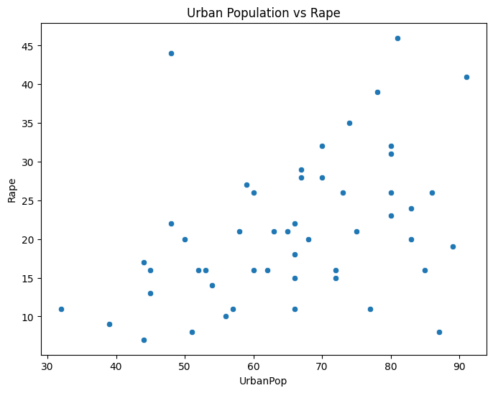
Scatter plot Rape vs Urban population. Illustrates the relationship between rape and urban population. Each point represents a state with x-axis showing the percentage of the population living in urban areas and the y-axis representing the rape rate per 100,000 population. The distribution of the data points indicates that there is no clear or strong linear relationship between urban population and rape cases. While some states with higher levels of urbanization also exhibit higher rape cases, many states with similar urban population percentages have considerably different rape rates. This suggest that urbanization alone does not account for the variation in rape rates across states.
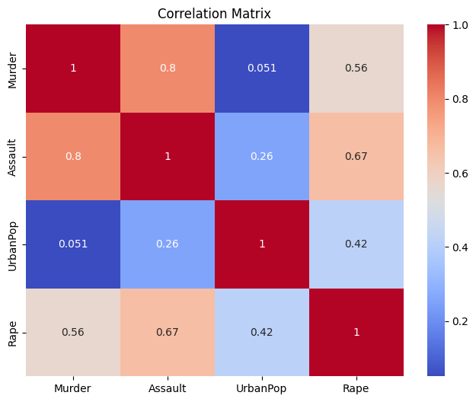
The correlation heatmap illustrates the strength and direction of the relationship between the four variables which are murder, assault, rape and urbanPop. Correlation coefficients range from -1 to 1 where values closer to 1 indicate a strong positive relationship, values of -1 indicate a strong negative relationship, and values near 0 indicate little or no linear relationship. The heatmap reveals a strong positive correlation between Murder and Assault, suggesting that states with higher murder rates also tend to have higher assault rates. The relationship between UrbanPop and the crime variable appear to be weaker, implying that the percentage of the population living in urban areas has only limited linear association with murder, assault and rape rates. The Rape variable shows a moderate positive correlation with both Murder and Assault indicating that states with higher rates of these crimes often also report higher rape rates. However, these relationships are not as strong as the correlation observed between murder and assault.

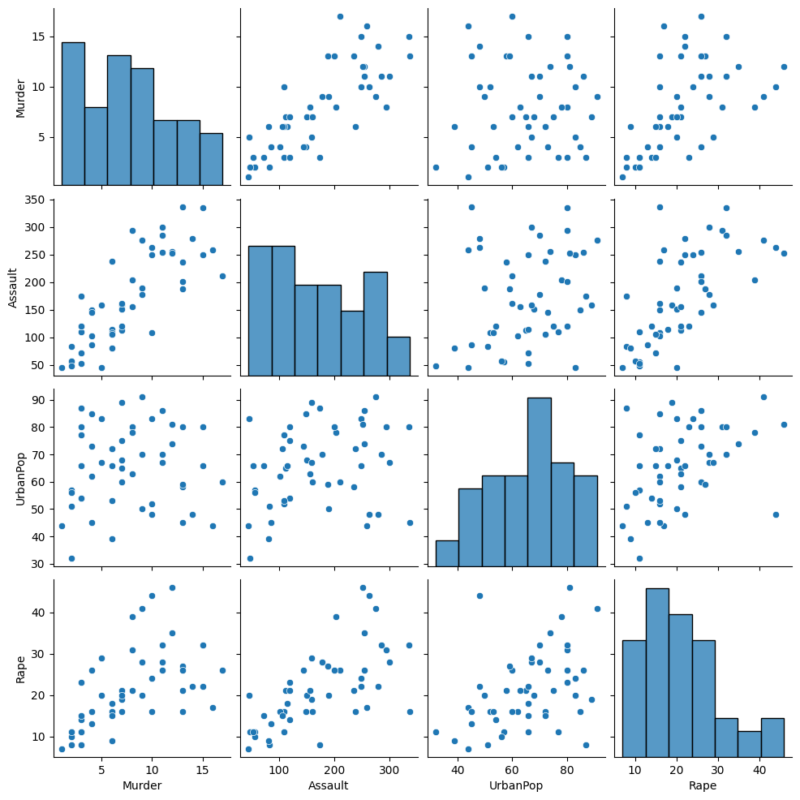
Pairplot, provides a comprehensive visual overview of the relationship amongst the four variables which are murder, assault, rape and urbanPop. The diagonal plots display the distribution of each variable individually, while the off-diagonal scatter plots illustrate the pairwise relationships between every combination of variables. The scatter plots indicate a strong positive relationship between murder and assault, as states with higher murder rates generally tend to have higher assault rates. There is also a moderate positive relationship between rape and both murder and assault, suggesting that these crime variables tend to increase together in some states.
The relationships involving urbanPop appear to be weaker and more dispersed with no clear linear trend observed between urban population and the crime variables. This suggest that the percentage of the urban population alone is not strong predictor of murder, assault or rape rates.

The report was written by Lungelo Ndabambi

